Report on Polar2018:
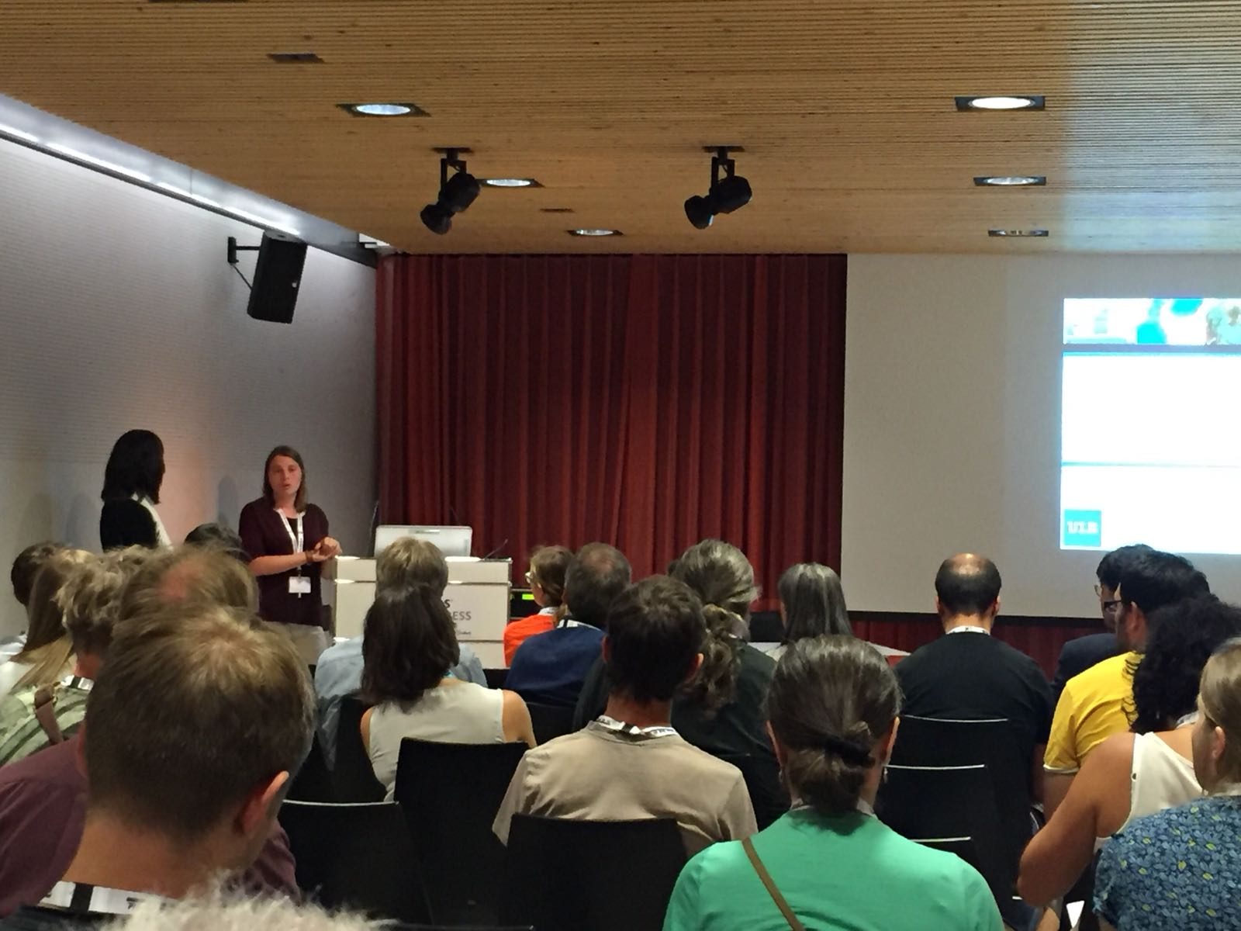
As early career researchers working on Antarctic case studies, attending SCAR conferences plays a crucial role to develop and integrate our projects within the Antarctic network. Polar 2018 was also the exceptional opportunity to combine and strengthen this network with the Arctic community. The conference was really helpful to open the scope of our research while being really productive with our already-existing network (related talks from peers, meeting during free time and side-events). Polar 2018 was finally the opportunity for us to present part of our results (1 talk and 5 posters) to a wide audience (3000 people), such an experience, thankfully possible with the ANTECO fellowship! =)

