Report on Polar2018
Polar2018 was beyond my expectations, in terms of the connections made and the opportunities created. I am extremely grateful for funds from both my department (Gateway Antarctica, University of Canterbury) and AntEco, which allowed me to attend one of the most important conferences in my field.
My experience started with planning the conference, for which I decided to attend both the business meetings held prior to Open Science Conference (OSC) and the Scientific Committee on Antarctic Research (SCAR) OSC. At first, I was nervous to go to some of these pre-meetings as an early career researcher (ECR), but the conveners welcome ECR’s into these meetings. I even got invited to participate in a potential new working group with SCAR Expert Group on Birds and Marine Mammals (EGBAMM), which will allow me to become involved with new projects. The OSC conference had not even begun and I was already gaining incredible opportunities, but the opportunities did not stop there.
During the OSC, I was able to talk to experts in my field from all over the world. Some of them even went out of their way to meet up with me and give me extra advice on methods and analysis techniques relevant to my PhD. I attended some of Association of Polar Early Career Scientists (APECS) World Summit 2018, where I met other ECR’s and felt very motivated to increase my involvement with APECS. I have since applied to join the APECS Council. I also attended some very empowering meetings, including Women in Polar Science and a new group, called Polar Pride. I am planning on getting more involved with minority group meetings, including developing a sector on Mental Health.
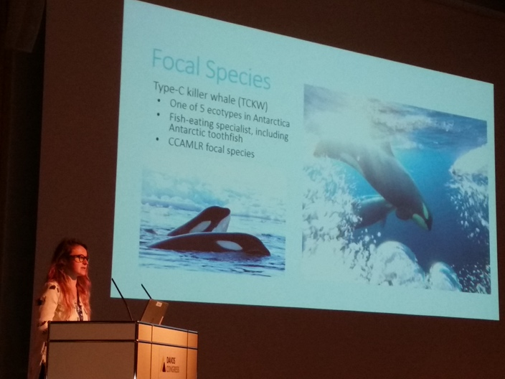
There were so many great experiences independent from what I came to Polar 2018 to do, an oral presentation. My oral presentation was the morning of the last day of the conference, so I had a lot of waiting to do. I was feeling slightly bad about not having many results, as my PhD is as much about developing a program for quicker analysis, as it is about the analysis. I was a bit worried, but mostly I was excited to get feedback from the community. The presentation went better than expected, as I got a lot of questions and feedback. I even got approached afterwards to be a potential researcher on an Antarctic research expedition, with researchers whose research helped get my interested in my career. The project is in the developmental stage, but it was nice to be asked if I would be interested in joining.
Photo: Regina Eisert
Overall, this experience has allowed me to gain experience giving conference oral presentations, meet experts in my field, gain valuable advice that I would not otherwise have been able to obtain, and form new connections and collaborative projects. As a first year PhD student, this experience was an extremely valuable part of developing my career and becoming more involved in the polar research community. I am excited for the next step in my career process and hope to further develop the connections and projects discussed during Polar 2018.

